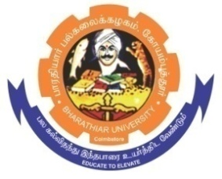
ghujpahh; gy;fiyf;fHfk;
BHARATHIAR UNIVERSITY
COIMBATORE – 641 046, TAMILNADU, INDIA

State University | Re-Accredited with “A++” Grade by NAAC | Ranked 21st among Indian Universities by MHRD-NIRF

TENDER INVITING NOTICE

E-Tender Notice No: BU/R-D2/Nano/Equip/3417/2023-24 Date: 26.04.2024

Online Bids are invited through Tamil Nadu Government e-Procurement Portal website:
www.tntenders.gov.in Tenders by Organisation Higher Education for the purchase of 1 No. of Co-Oxial spinneret additional spare part for already exiting Electrospinning unit for the Department of Nanoscience and Technology in Bharathiar University, Coimbatore.
The Bid submission is extended up to 02.05.2024 @ 3.00PM.

REGISTRAR i/c.

Website: www.b-u.ac.in ٭ E-Mail: regr@buc.edu.in ٭ Phone: 0422-2428108/2428126 ٭Fax: +91 422 2425706

